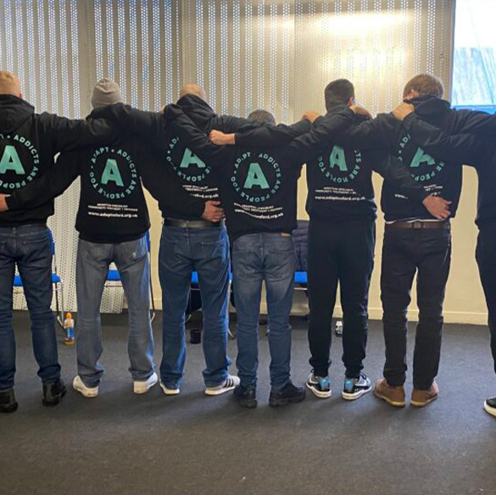
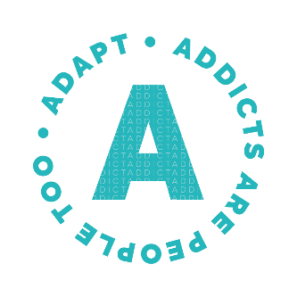

Introduction to ADAPT …
Who We Are
ADAPT is a charity based in Oxfordshire, dedicated to providing supported housing and a bespoke day programme for individuals seeking to rebuild their lives free from substance dependency. Our holistic approach ensures that every resident receives the support they need to achieve lasting recovery and reintegrate into the community with dignity and purpose.
Our Mission
At ADAPT, our mission is to empower individuals to overcome the challenges of addiction by providing a safe, supportive environment that fosters personal growth, resilience, and hope.
What We Do
- Supported Housing: We offer stable accommodation for those on the path to recovery, creating an environment that supports positive change and long-term independence.
- Bespoke Day Programme: Operating five days a week, our structured programme includes therapy sessions led by qualified counsellors, life skills workshops, and peer support activities tailored to each individual’s needs.
- Community Integration: We believe in the power of community. ADAPT helps residents build supportive relationships and develop the skills necessary to thrive in their personal and professional lives.
Why We Exist
Substance dependency can have devastating effects on individuals, families, and communities. Many people leaving rehabilitation face significant barriers to sustaining recovery, including lack of stable housing, social isolation, and stigma. ADAPT bridges this critical gap by offering a safe and nurturing space where individuals can focus on their recovery journey with the guidance and support of our dedicated team.
Our Impact
ADAPT has supported countless individuals to reclaim their lives from addiction. By providing a foundation for recovery, we contribute to stronger, healthier communities across Oxfordshire and beyond.


Becoming a Trustee…
Overview of the Role
As a trustee of ADAPT, you will play a vital role in shaping the strategic direction and governance of our charity. Trustees ensure that ADAPT operates effectively, upholds its mission, and complies with legal and financial obligations. This is an exciting opportunity to contribute your skills and experience to make a meaningful impact on the lives of individuals overcoming substance dependency.
Key Responsibilities
- Strategic Oversight: Collaborate with fellow trustees to set ADAPT’s vision, mission, and long-term goals.
- Governance and Compliance: Ensure ADAPT complies with all legal and regulatory requirements, including charity law and safeguarding standards.
- Financial Stewardship: Monitor the charity’s financial health, approve budgets, and oversee the effective use of resources to achieve our objectives.
- Advocacy and Ambassadorship: Act as an advocate for ADAPT, promoting our work and raising awareness about the challenges faced by those in recovery.
- Support and Guidance: Provide advice and expertise to the executive team, helping to address challenges and seize opportunities.

Person Specification:
We are seeking individuals with a passion for our mission and the skills, experience, and commitment to help guide ADAPT’s work. Trustees come from a variety of backgrounds, and we value diversity of thought, experience, and perspective. While prior trustee experience is not required, candidates should meet the following criteria:
Essential Qualities and Skills
- Commitment to ADAPT’s Mission and Values: A genuine interest in supporting individuals on their journey to recovery and a belief in ADAPT’s holistic approach to care.
- Strategic Thinking: The ability to think critically and contribute to the development of long-term strategies and goals.
- Good Judgment and Decision-Making: A considered and fair approach to evaluating options and making decisions in the best interests of the charity.
- Teamwork and Collaboration: Willingness to work as part of a diverse board and support the executive team in achieving shared goals.
- Time Commitment: Availability to attend trustee meetings (typically quarterly) and participate in additional sub-committees or events as required.
Desirable Skills and Experience
While not essential, we welcome candidates with expertise in one or more of the following areas:
- Finance or Accounting: Experience managing budgets, financial planning, or charity accounts.
- Legal or Governance Knowledge: Familiarity with charity law, safeguarding, or governance frameworks.
- Fundraising and Development: Insights into securing funding, donor engagement, or grant writing.
- Communications and Advocacy: Skills in public relations, marketing, or advocacy to help raise ADAPT’s profile.
- Lived Experience or Professional Background in Addiction Support: An understanding of the challenges faced by individuals in recovery.
Inclusivity
ADAPT is committed to building a diverse and inclusive board of trustees. We encourage applications from individuals of all backgrounds, particularly those with lived experience or underrepresented perspectives in the charity sector.

Have you got what we’re looking for?
What’s in it for you…
Becoming a trustee at ADAPT is a deeply rewarding experience that offers opportunities for personal growth, professional development, and the chance to make a meaningful impact. Here’s what you can gain from joining us:

Make a Real Difference
- Contribute to a cause that transforms lives and helps individuals build a future free from addiction.
- See the tangible impact of your work in the lives of those we support and the broader community.

Expand Your Skills and Experience
- Develop strategic thinking and leadership skills as part of a dedicated and diverse board.
- Gain insights into charity governance, financial management, and organisational decision-making.
- Enhance your professional portfolio with experience in a meaningful, mission-driven environment.

Collaborate with Like-Minded People
- Join a team of passionate and skilled individuals committed to a shared purpose.
- Build relationships with other trustees, staff, and supporters, expanding your professional network.

Personal Fulfillment
- Share your expertise and give back to the community in a way that aligns with your values.
- Be part of a supportive and compassionate team working to bring about positive change.

Flexibility and Support
- ADAPT recognises the demands on your time and offers a flexible commitment designed to fit around your existing responsibilities.
- Training and induction are provided to ensure you feel confident and equipped in your role.


Still have questions?
We’d love to hear from you! If you have any additional queries or would like to discuss the trustee role further, please don’t hesitate to contact us on 07786 557104. Your journey to making a difference starts here!

Do I need previous trustee experience to apply?

No, we welcome applications from individuals with a variety of backgrounds and experiences. We value enthusiasm, commitment, and the willingness to learn.

How much time will I need to commit?

Trustees typically attend four board meetings per year, each lasting around two to three hours. Additional time may be required for sub-committee work, reading papers, or attending events, but we aim to remain flexible around your availability.

Do I need to live in Oxfordshire to be a trustee?

While it’s helpful to have local knowledge, it’s not a requirement. Some meetings can be attended remotely, but trustees are encouraged to engage with the charity’s work and events whenever possible.

Is the role paid?

No, trustee roles are voluntary. However, reasonable expenses such as travel costs can be reimbursed.

What skills or experience are you looking for?

We’re looking for a range of skills, including finance, fundraising, legal expertise, governance, and communications. We also value lived experience of recovery or addiction support, but most importantly, we want individuals who are passionate about ADAPT’s mission.

What’s the application process?

After expressing interest, you’ll be invited to submit a brief application, followed by an informal discussion with current trustees. This is an opportunity for us to get to know each other and answer any questions you might have.

What’s the term length for a trustee?

Trustees are usually appointed for a three-year term, with the option to renew for a second term if desired.

Will I need to attend fundraising events?

While it’s not mandatory, we encourage trustees to participate in events whenever possible, as it’s a great way to connect with the community and support our work.

FAQs…

